**Q1.**

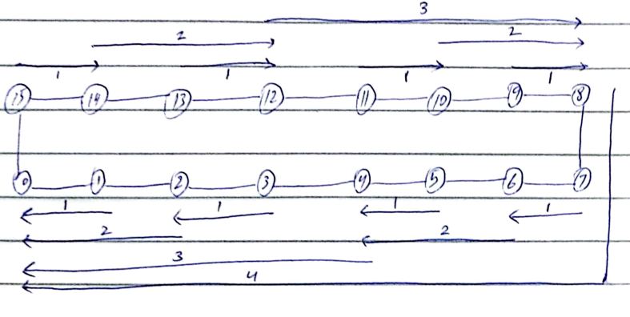

**Q2.**

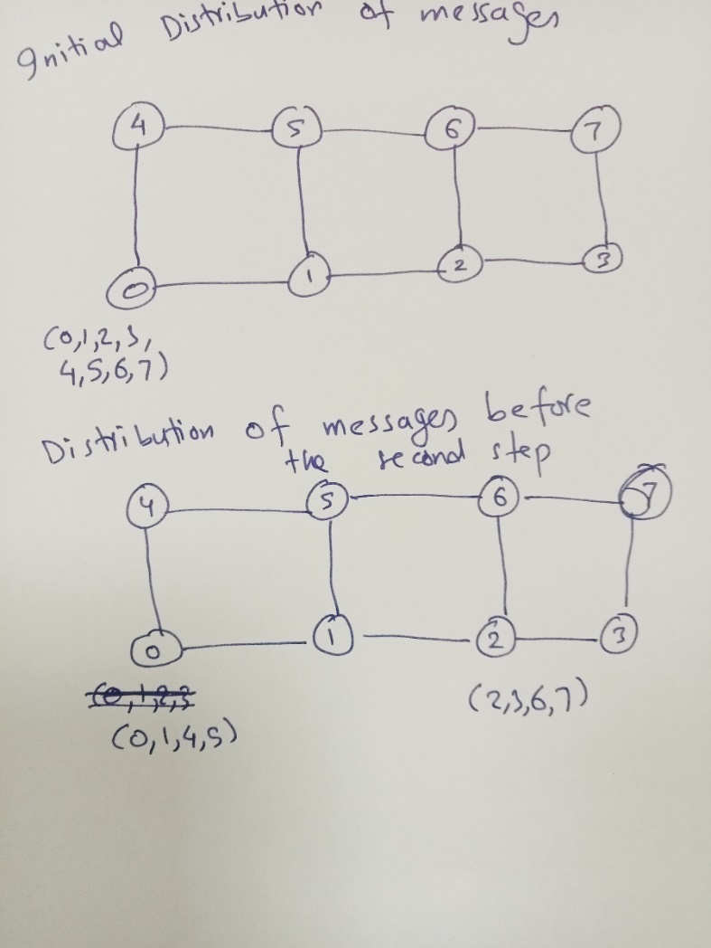

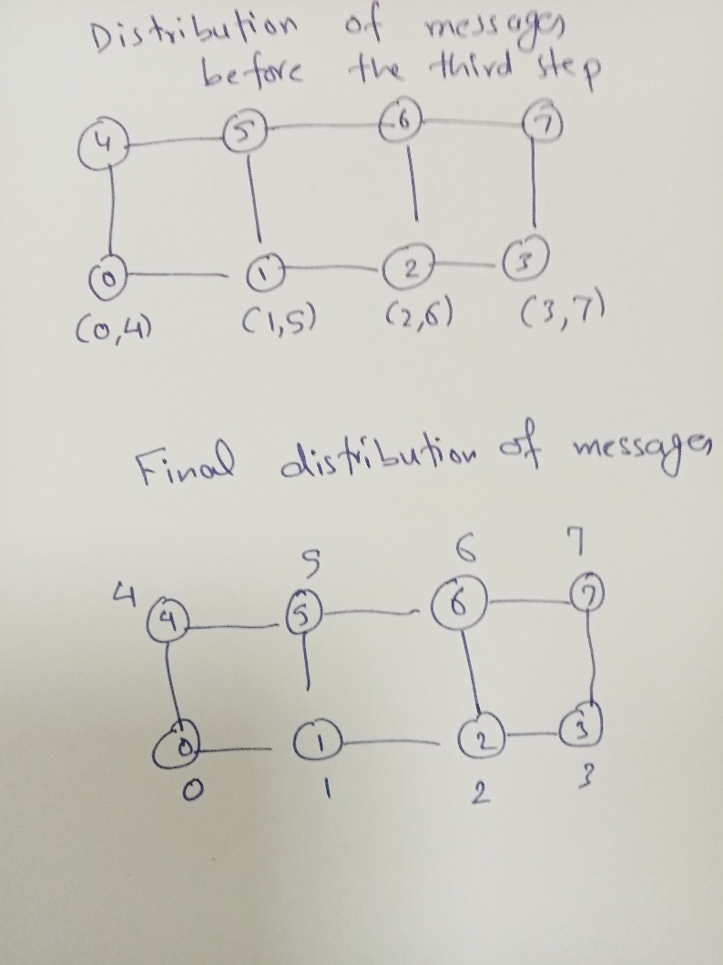

Communication cost (first step) = ts + 4m tw

Communication cost (second step) = ts + 2m tw

Communication cost (third step) = ts + m tw

Total communication cost = 3ts + 7m tw

**Q3.**

|  |
| --- |
| **Output:**  **At thread: 0 iteration: 0**  **At thread: 0 iteration: 1**  **At thread: 0 iteration: 2**  **At thread: 0 iteration: 3**  **At thread: 1 iteration: 4**  **At thread: 1 iteration: 5**  **At thread: 1 iteration: 6**  **At thread: 1 iteration: 7**  **At thread: 2 iteration: 8**  **At thread: 2 iteration: 9**  **At thread: 2 iteration: 10**  **At thread: 2 iteration: 11**  **4 10 18 28 40 54 70 88 108 130 154 180** |

**Q4.**

Solution:

1. Output=45
2. Sum variable:

* Each thread computes its local thread_sum independently.
* When all iterations are complete, each thread enters the #pragma omp critical section to add its thread_sum to the shared variable sum.
* Since the critical section is synchronized, only one thread can update sum at a time, ensuring the correct final result.

***Q5.***

